**Assignment-based Subjective Questions**

1. From your analysis of the categorical variables from the dataset, what could you infer about their effect on the dependent variable?

ANS:

The categorical variables have different effect on categorical variables

1.according to 'season' the count in spring and winter is low compared to summer and fall

2. according to 'holiday' the count in holiday (0) is higher and on non-holiday is low

3.according to 'workingday' the count is almost the same for both the cases.

4.according to 'weathersit' the count in 'Mist + Cloudy, Mist + Broken clouds, Mist + Few clouds, Mist' is higher

5.according to 'mnth' the count in the mid of the year is higher than the staring and in the end.

6.according to 'weekday' the count is almost same throughout the week.

7.according to 'yr' the count has substantially increased from previous year

-------------------------------------------------------------------------------------------------------------------------------------

1. Why is it important to use drop_first=True during dummy variable creation?

ANS:

drop_first=True is important to use, as it helps in reducing the extra column created during dummy variable creation. Hence it reduces the correlations created among dummy variables.

-------------------------------------------------------------------------------------------------------------------------------------

1. Looking at the pair-plot among the numerical variables, which one has the highest correlation with the target variable?

ANS:

1. ‘casual’ and ‘**registered**’ are having highly corelated 0.672123 and 0.945411 respectively as they are the subset of our target variable ‘**cnt**’
2. **‘temp’** and **‘atemp’** have correlation value of0.627044 and 0.630685which is second in the list
3. **‘hum’** and **‘windspeed’** have negative correlation with target variable**.**
4. How did you validate the assumptions of Linear Regression after building the model on the training set?

ANS**:**

1. We can plot the graph Plotting y_test and y_pred to understand the spread . If the grapgh
2. We can see the r2 score of the y_test and y_pred.
3. We check for the normal distribution of the error terms.

**----------------------------------------------------------------------------------------------------------------------------------------------------**

1. Based on the final model, which are the top 3 features contributing significantly towards explaining the demand of the shared bikes?

ANS:

* Temp
* Yr
* season_fall

-----------------------------------------------------------------------------------------------------------------------------------

**General Subjective Questions**

1. Explain the linear regression algorithm in detail?

ANS :

Linear regression is one of the easiest and most popular Machine Learning algorithms. It is a statistical method that is used for predictive analysis. Linear regression makes predictions for continuous/real or numeric variables such as **sales, salary, age, product count,** etc.

Linear regression algorithm shows a linear relationship between a dependent (y) and one or more independent (X) variables, hence called as linear regression. Since linear regression shows the linear relationship, which means it finds how the value of the dependent variable is changing according to the value of the independent variable.

The linear regression model provides a sloped straight line representing the relationship between the variables.

Equation for linear regression algo:

y= a0+a1X+ ε

Y= Dependent Variable (Target Variable)

x= Independent Variable (predictor Variable)

a0= intercept of the line

a1 = Linear regression coefficient

ε = random error

**Types of Linear Regression**

1. **Simple Linear Regression:**  If a single independent variable is used to predict the value of a numerical dependent variable, then such a Linear Regression algorithm is called Simple Linear Regression.
2. **Multiple Linear regression:** If more than one independent variable is used to predict the value of a numerical dependent variable, then such a Linear Regression algorithm is called Multiple Linear Regression.

**-----------------------------------------------------------------------------------------------**

1. Explain the Anscombe’s quartet in detail.

ANS :

**Anscombe’s Quartet**can be defined as a group of four data sets which are **nearly identical in simple descriptive statistics**, but there are some peculiarities in the dataset that **fools the regression model**if built. They have very different distributions and **appear differently**when plotted on scatter plots.

Anscombe’s quartet comprises four datasets that have nearly identical simple statistical properties, yet appear very different when graphed. Each dataset consists of eleven (x,y) points. They were constructed in 1973 by the statistician Francis Anscombe to demonstrate both the importance of graphing data before analyzing it and the effect of outliers on statistical properties.

Once Francis John “Frank” Anscombe who was a statistician of great repute found 4 sets of 11 data-points in his dream and requested the council as his last wish to plot those points. Those 4 sets of 11 data-points are given below.

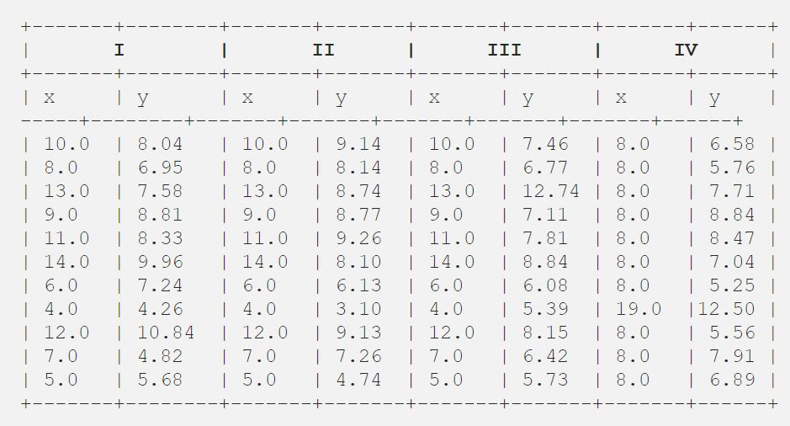

--------------------------------------------------------------------------------------------------------------------------

1. What is Pearson’s R?

ANS:

The **Pearson correlation coefficient (*r*)** is the most common way of measuring a linear correlation. It is a number between –1 and 1 that measures the strength and direction of the relationship between two variables.

Between 0 and 1 - Positive correlation ( When one variable changes, the other variable changes in the **same direction**.)

0 - No correlation (There is **no relationship** between the variables.)

Between 0 and –1 - Negative correlation ( When one variable changes, the other variable changes in the **opposite direction**.)

| **Pearson correlation coefficient (*r*) value** | **Strength** | **Direction** |
| --- | --- | --- |
| Greater than .5 | Strong | Positive |
| Between .3 and .5 | Moderate | Positive |
| Between 0 and .3 | Weak | Positive |
| 0 | None | None |
| Between 0 and –.3 | Weak | Negative |
| Between –.3 and –.5 | Moderate | Negative |
| Less than –.5 | Strong | Negative |
|  |  |  |
|  |  |  |

Another way to think of the Pearson correlation coefficient (*r*) is as a measure of how close the observations are to a [line of best fit](https://www.scribbr.com/statistics/simple-linear-regression/#how-to-perform-a-simple-linear-regression).

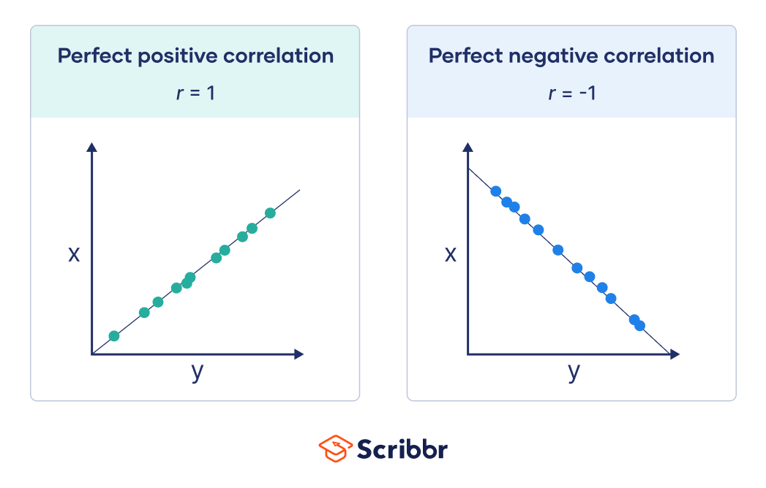

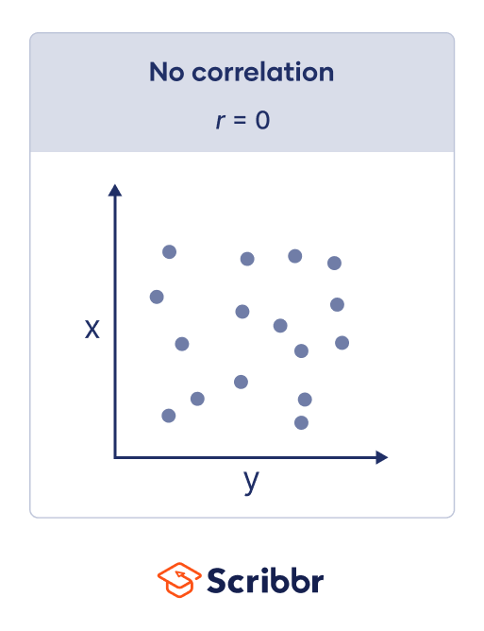

1. What is scaling? Why is scaling performed? What is the difference between normalized scaling and standardized scaling?

ANS:

It is a step of data Pre-Processing which is applied to independent variables to normalize the data within a particular range. It also helps in speeding up the calculations in an algorithm.

Most of the times, collected data set contains features highly varying in magnitudes, units and range. If scaling is not done then algorithm only takes magnitude in account and not units hence incorrect modelling. To solve this issue, we have to do scaling to bring all the variables to the same level of magnitude.

It is important to note that **scaling just affects the coefficients** and none of the other parameters like **t-statistic, F-statistic, p-values, R-squared**, etc.

Normalization/Min-Max Scaling:

It brings all of the data in the range of 0 and 1. sklearn.preprocessing.MinMaxScaler helps to implement normalization in python.

m = (x -xmin) / (xmax -xmin)

Standardization Scaling:

Standardization replaces the values by their Z scores. It brings all of the data into a standard normal distribution which has mean (μ) zero and standard deviation one (σ).

z = (x - u) / s

1. You might have observed that sometimes the value of VIF is infinite. Why does this happen?

ANS : If there is perfect correlation, then VIF = infinity. This shows a perfect correlation between two independent variables. In the case of perfect correlation, we get R2 =1, which lead to 1/(1-R2) infinity. To solve this problem we need to drop one of the variables from the dataset which is causing this perfect multicollinearity.

An infinite VIF value indicates that the corresponding variable may be expressed exactly by a linear combination of other variables (which show an infinite VIF as well).

1. What is a Q-Q plot? Explain the use and importance of a Q-Q plot in linear regression.

ANS :

Q-Q plots are also known as Quantile-Quantile plots. As the name suggests, they plot the quantiles of a sample distribution against quantiles of a theoretical distribution. Doing this helps us determine if a dataset follows any particular type of probability distribution like normal, uniform, exponential.

**Normal distributions**

We regularly make the assumption of normality in our distribution as we perform statistical analysis and build predictive models. Machine learning algorithms like linear regression and logistic regression perform better where numerical features and targets follow a Gaussian or a uniform distribution.

It’s an important assumption as normal distribution allows us to use the empirical rule of 68 – 95 – 99.7 and analysis where we can predict the percentage of values and how far they will fall from the mean.

In regression models, normality gains significance when it comes to error terms. You want the mean of the error terms to be zero. If the mean of error terms is significantly away from zero, it means that the features we have selected may not actually be having a significant impact on the outcome variable. It’s time to review the feature selection for the model.